FISHERIES STUDENT’S ASSOCIATION OF MAKERERE UNIVERSITY
(FISAMU)
HISTORY
This association was founded in 2004 by the then president, Mr.Muwonge Gilbert Bengo. It is a registered association with the students Guild and the registration was confirmed on 29th.October.2008. It belongs to the College Of Natural Science (CONAS).
THE OBJECTIVE
The aim of this students association is to bring together all the fisheries students of this great institution on board, both the alumni and the present students.
THE PATRON
We have a patron, Dr.Gladys Bwanika who is also one of dearest lecturers at Department of Zoology, Entomology and Fisheries Science. She has been there for us ever since and we pray that God/Allah rewards her abundantly as she continues to be with us.
ACTIVITIES
We carry out alo of activiies both academic and social ones, the academic ones includes: the yearly visi to Kajjansi fish farm in Entebbe, celebrations of the World Fisheries’Day on 21st Novermber, Exhibition on Science Day which starts three days earlier and climaxed on 10th Oct, the World Science Day, maintenance and renoviations of our two aquria , one on the ground floor of JICA building and another one in the Basement of Our Department of Zoology, Entomology and Fisheries Science.
The social activities include: the yearly enjoyable Beach Bash to welcome fresher,FISAMU organizes the swimming gala between year-1, year-2, and year-3, Like any other organization FISAMU hold elections democratically, FISAMU dinner for our dear finalists coupled with the executive handover.
LEADERSHIP STRUCTURE
We have a well-organized leadership structure which include; the president, the vice president, general secretary, the speaker, deputy speaker, treasurer, the information minister, project coordinator, deputy project coordinator, GRC, minister without portfolio and representatives of all year of studies and alumni.

NAMES OF THE CABINENT MEMBERS 2016/2017
WE ARE HUMBLED TO HAVE;
NAME | POST
NAZZIWA CATHY | President
KASULE JONATHAN | Vice -president
SSEWANYANA ABDUL | Speaker
KABALIISA PEACE | General Secretary
SSONKO JULIUS | Treasurer
WANDERA CHESTER | Deputy Speaker
MUSINGUZI JAMIL | Project-coordinator
KAZIBWE VICTOR ALLAN | Deputy project coordinator
MATOVU S TREVOR | GRC
SEGUYA DENIS | Information minister
KIWANUKA ALAPHAT | Year 3 representative
KISENYI AMOS | Year 2 representative
MUWONGE STEVEN | Year 1 representative
NAWOOVA DOROTHY | Minister without portfolio

EXECUTIVES GROUP PHOTO 2016/2017

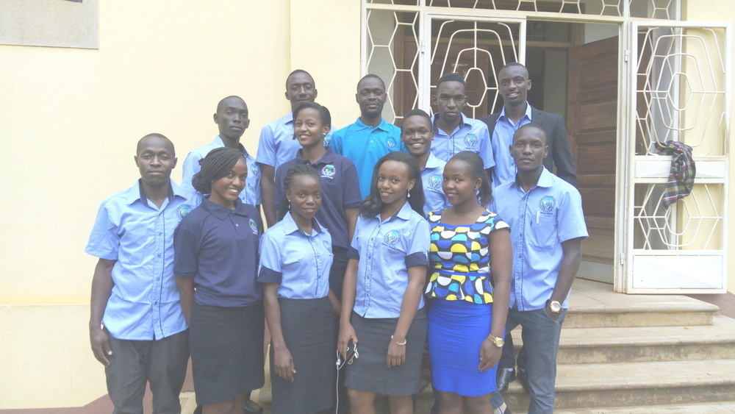FISAMU STICKER

FISAMU WEB-SITE
HOW TO ACCESS IT
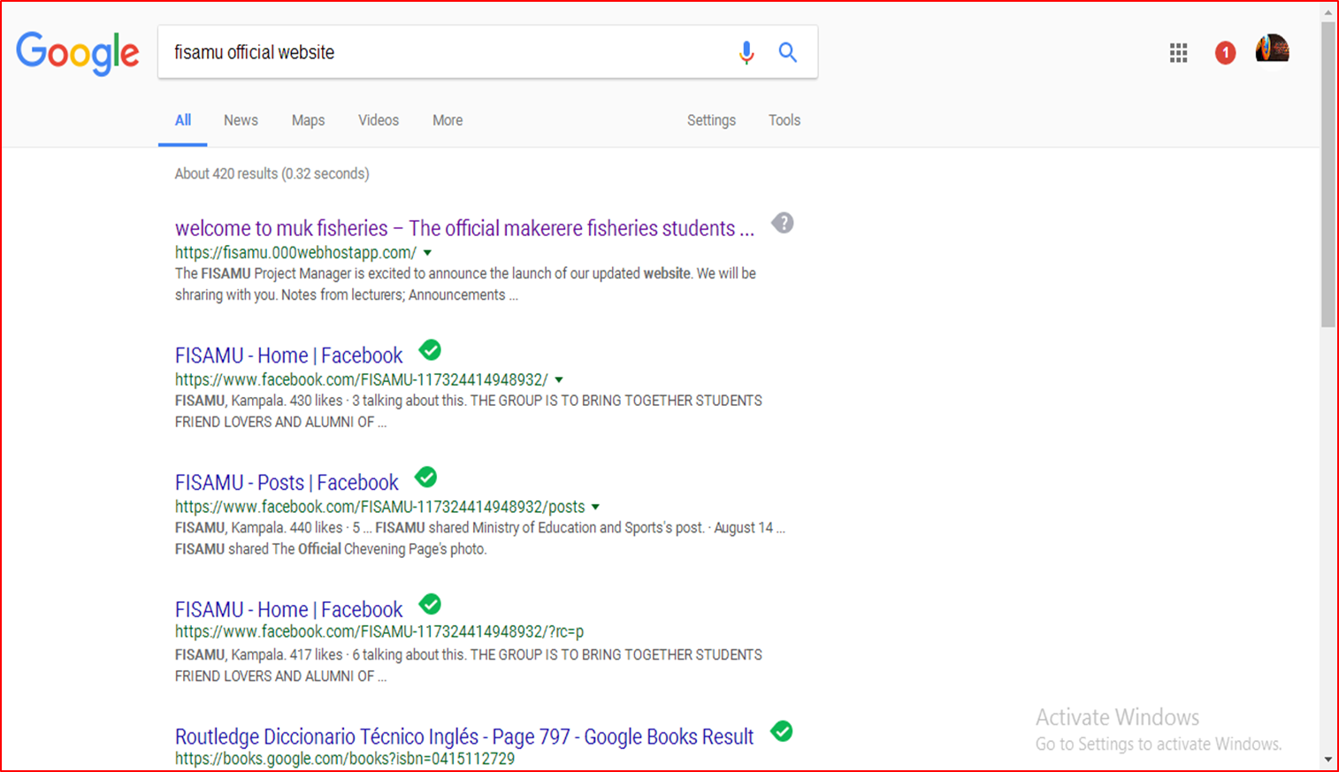

FISAMU APP
You can access the FISAMU website through our android app
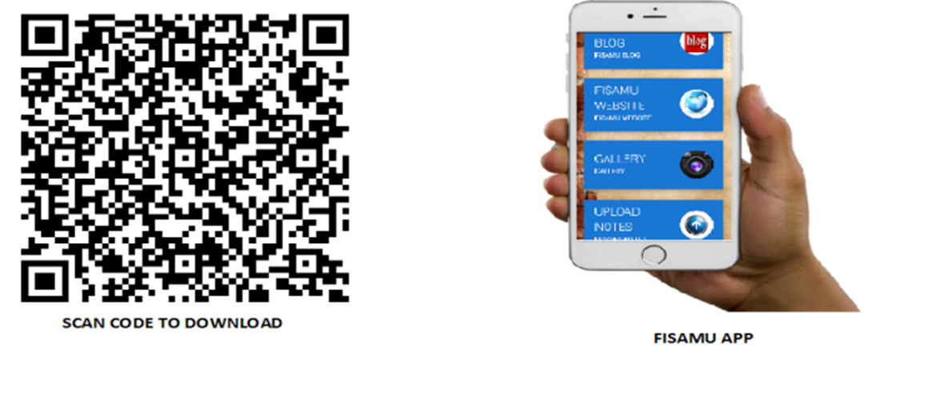
FISAMU LOG
FISAMU SWIMMING GALA
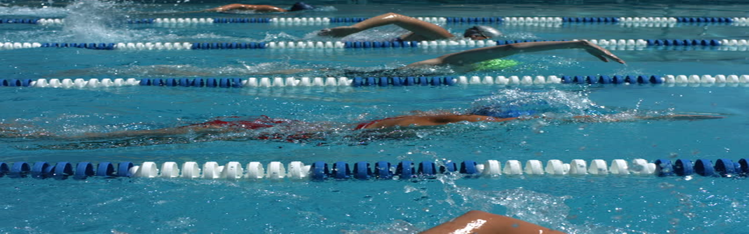
AQUARIAM
1. Located on the ground floor of JICA building
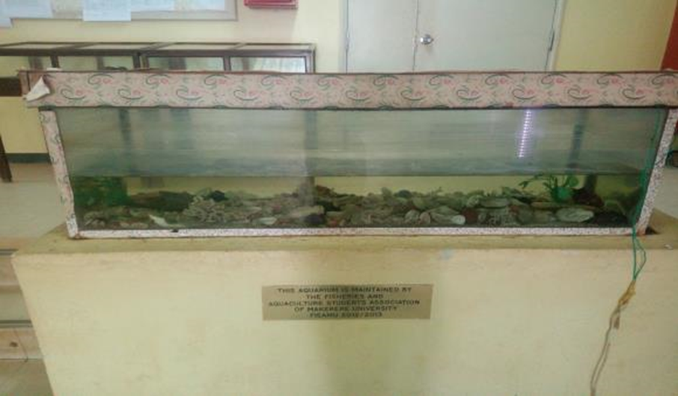
2. Located atIvory lab basement.
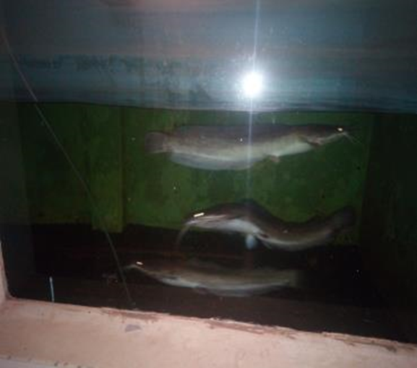

SAMPLE OF THE FISAMU CERTIFICATE

